**LAB 03**

**IPs OF VIRTUAL MACHINES**

Victim’s IP: 10.0.2.5

Client’s IP: 10.0.2.6

Attacker’s IP: 10.0.2.4

**CHECKING REDIRECTION PROTOCOLS OF VMs**

**Client:**

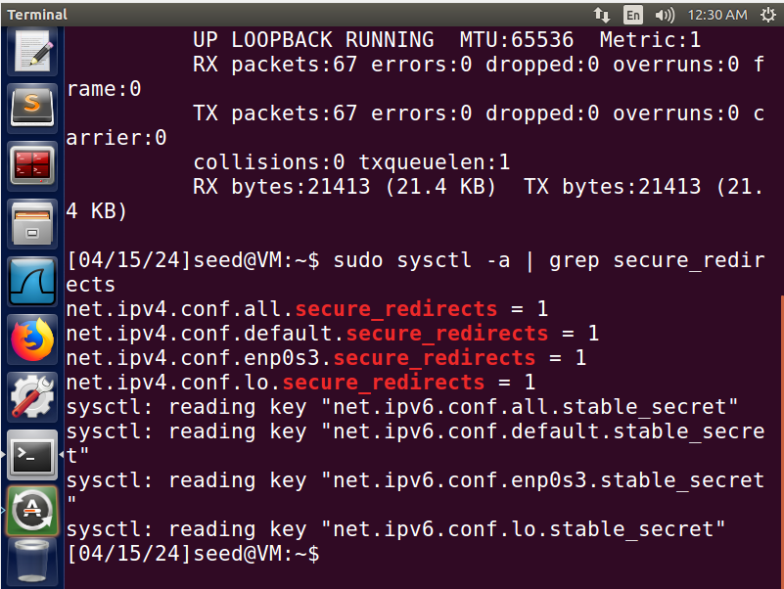

**Victim:**

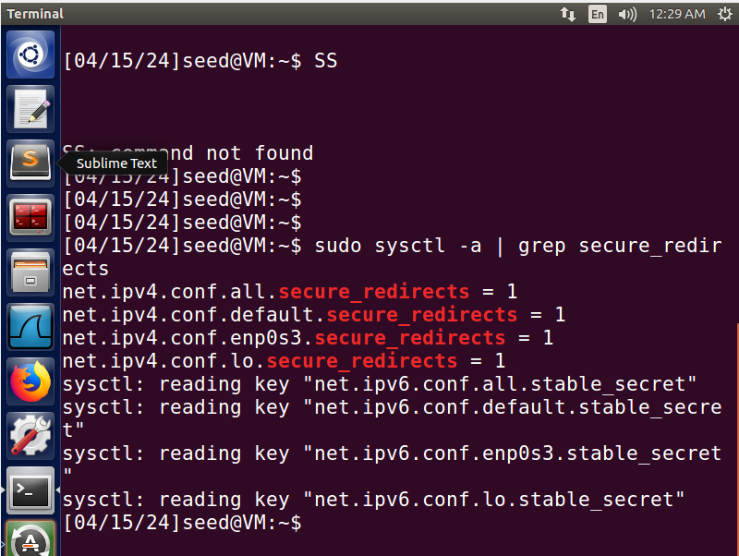

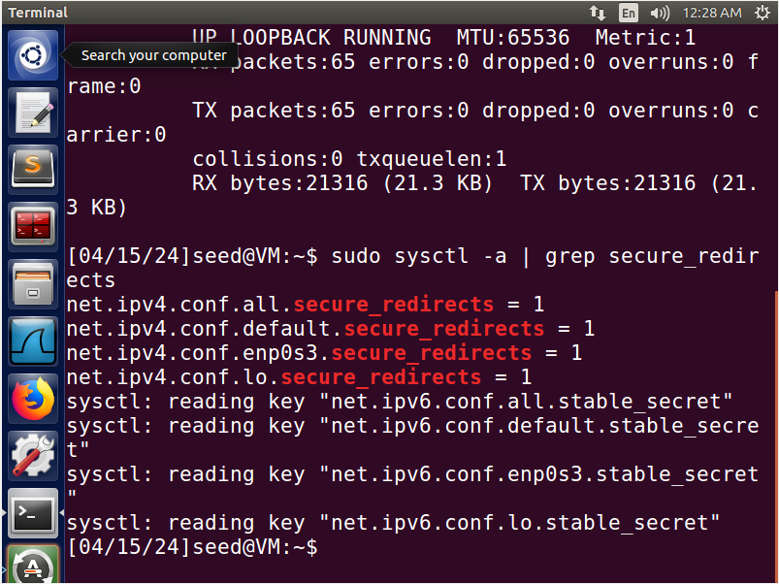**Attacker:**

**CHANGING REDIRECT PROTOCOLS**

**Attacker:**

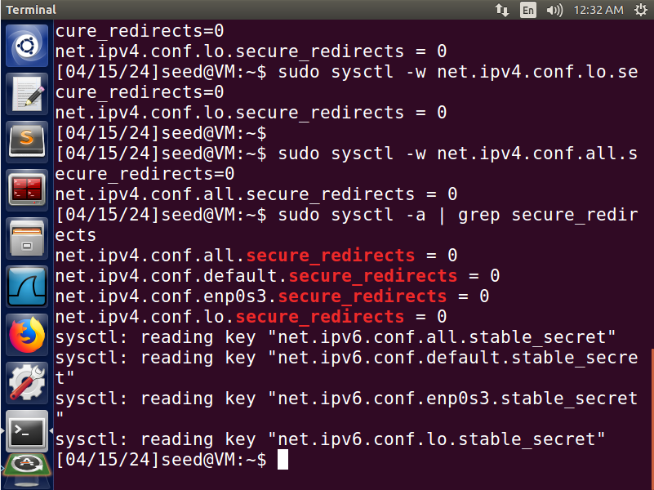

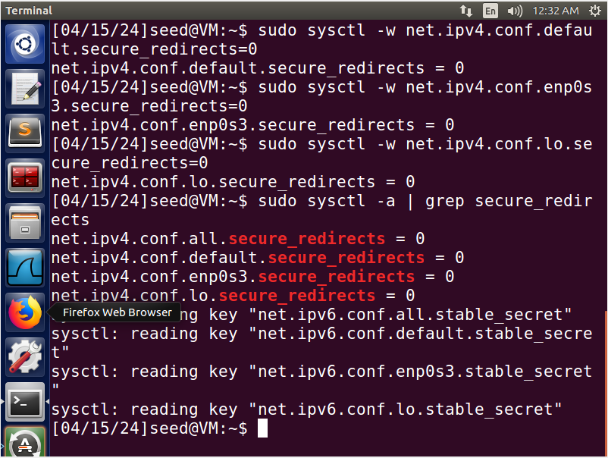**Victim:**

**LAUNCH ATTACK**



**CHECKING THE CONNECTION**

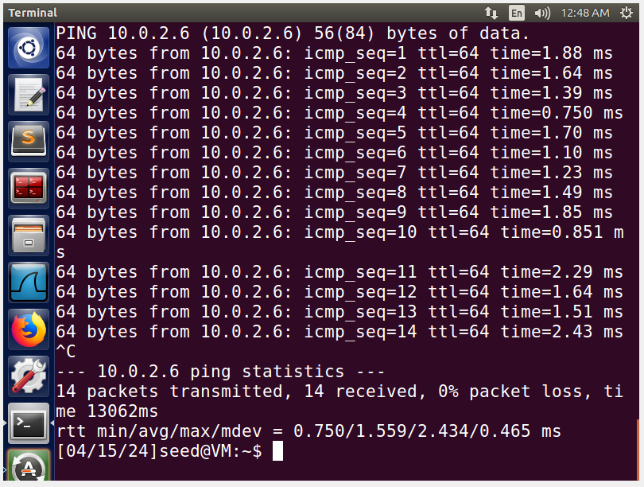

**REDIRECTION IN WIRESHARK**

